**Quick Latex Guide**

1. **Installation:**

Front End- TexMaker

<http://www.xm1math.net/texmaker/>

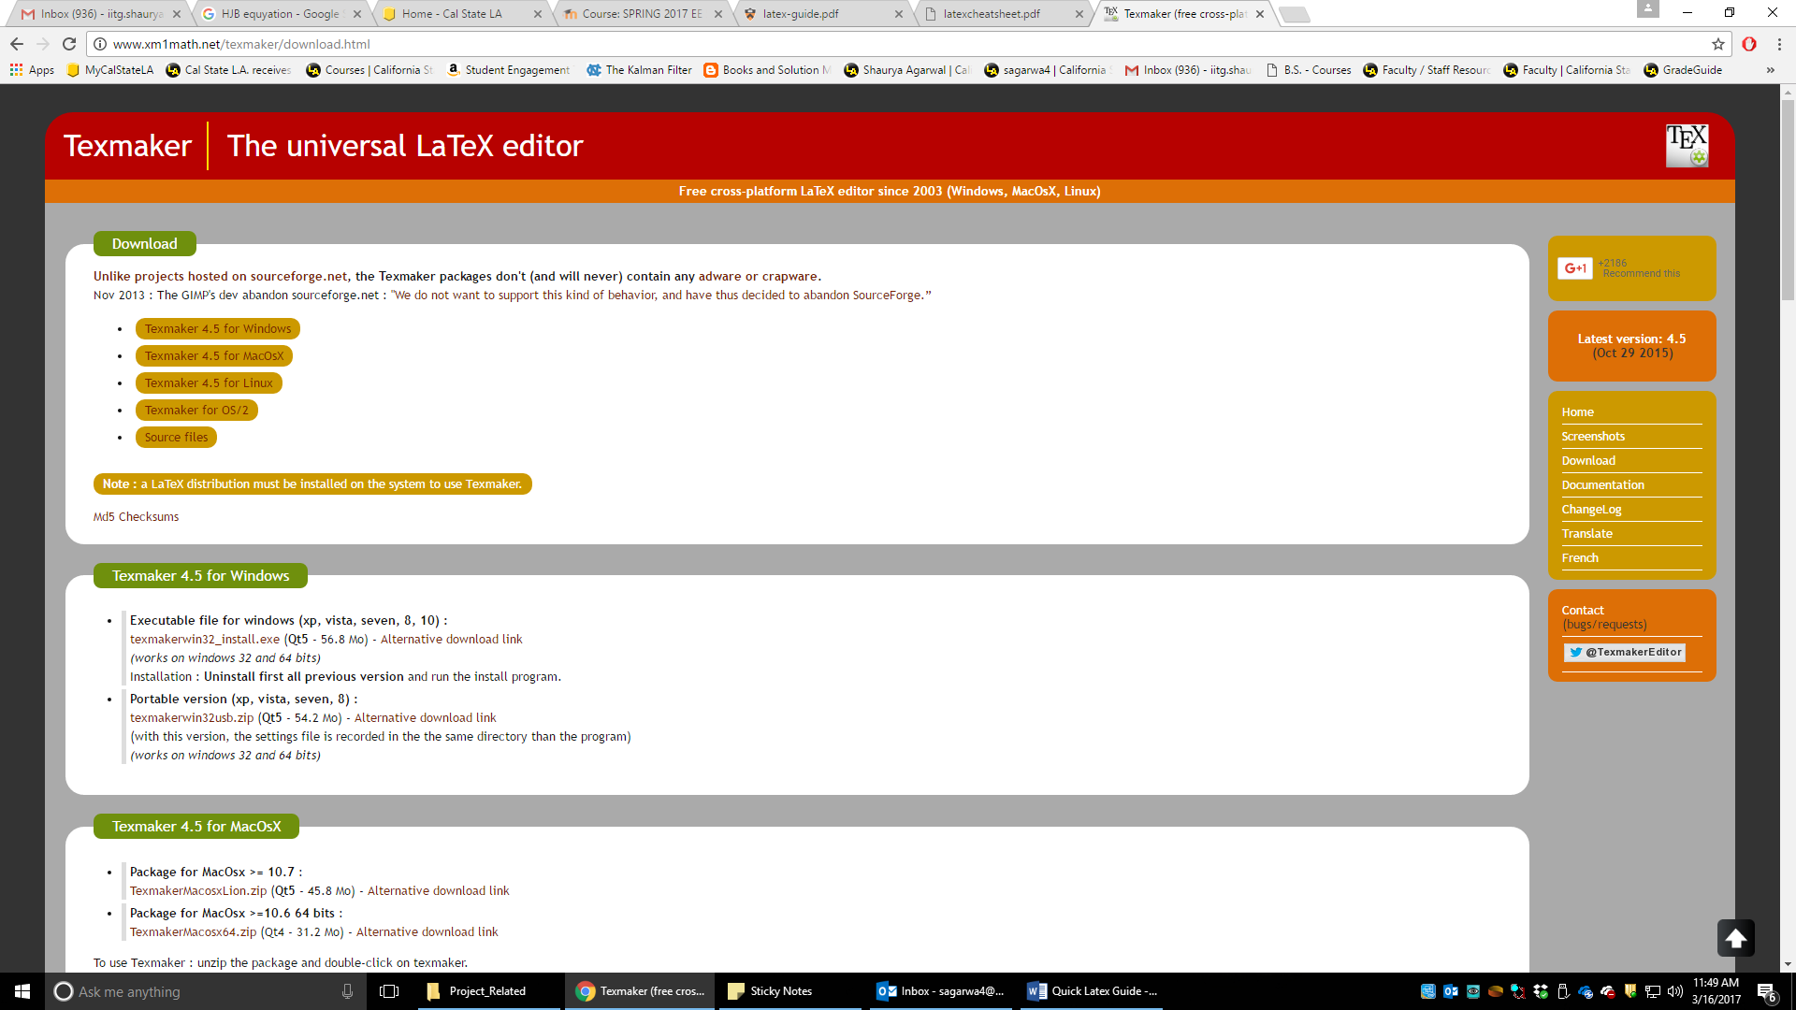

Backend- MikTex

<https://miktex.org/download>

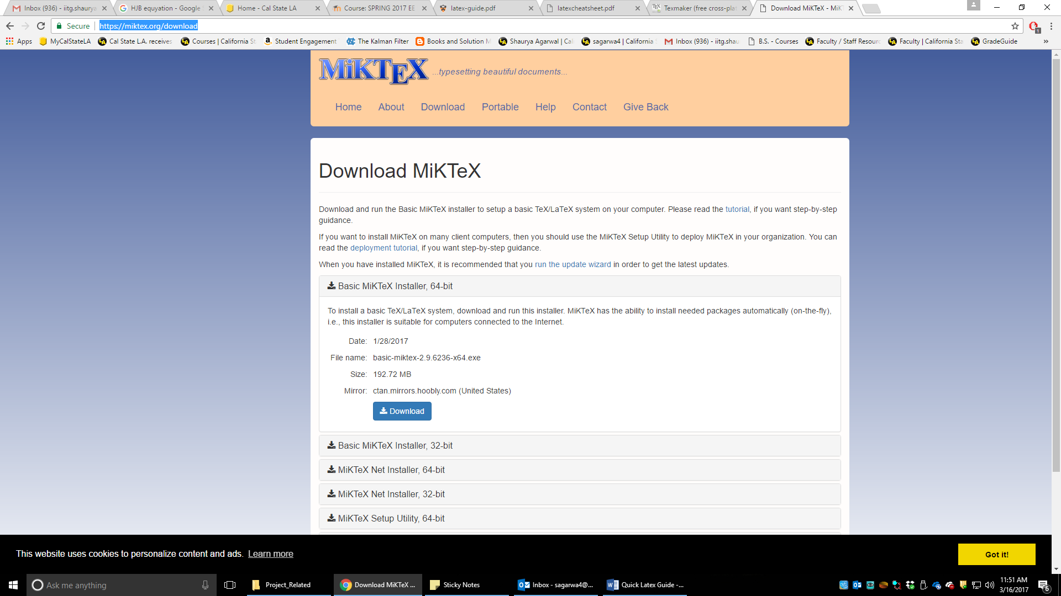

**Remember**- to choose “automatically install packages on the fly” while installing MikTex. This will be very helpful later on.

1. Once your installation is complete, open the proposal template and compile it using “quickbuild” option. You should go to options->configure texmaker->quickbuild->choose 3rd option.

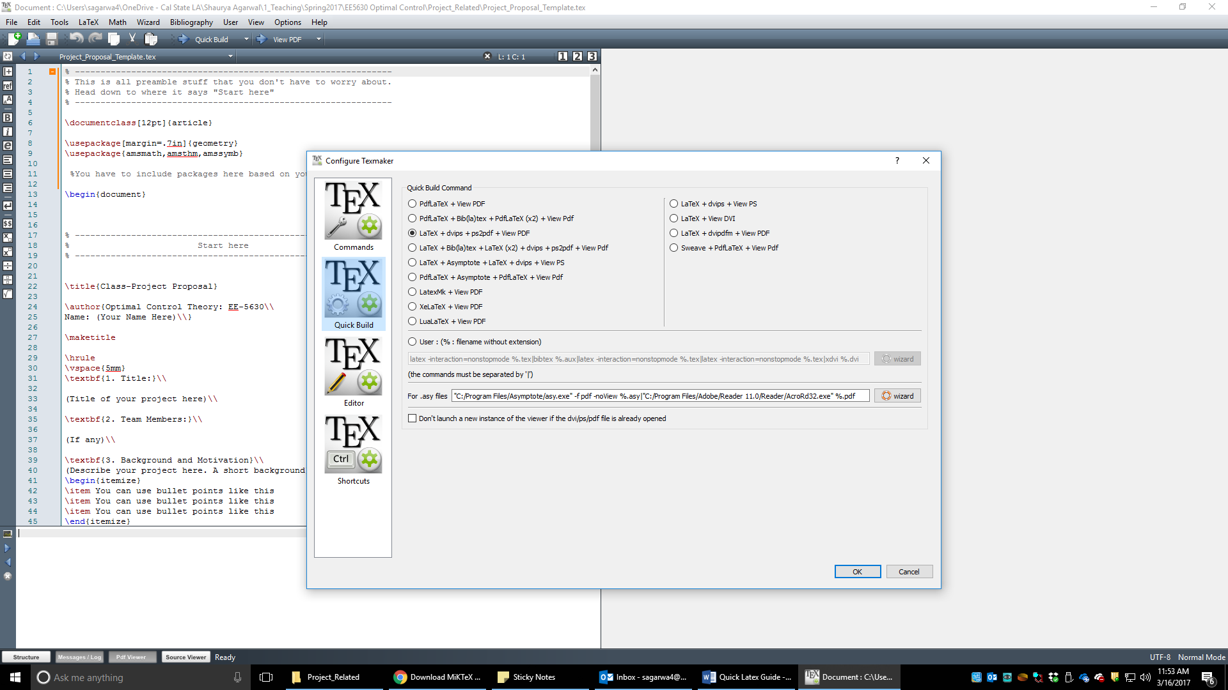

1. You are all set! Compile the template. Add more as you like.
2. For adding tables, figures and equations, use online resources such as wikibooks for code snippets. Some very useful resources are:

<https://en.wikibooks.org/wiki/LaTeX/Floats,_Figures_and_Captions>

<https://www.codecogs.com/latex/eqneditor.php>

Lastly, let me emphasize, LaTex is VERY POWERFUL tool. Once you cross that initial learning curve, you will enjoy it a lot!

Note: there are lot of latex compilation tools. TexMaker and Miktex are the two that I use.